Date

The corona style

# Surviving in curfew times

* Then at once it went,,, the president set out working hours from to reduce the spread of the dreadfully co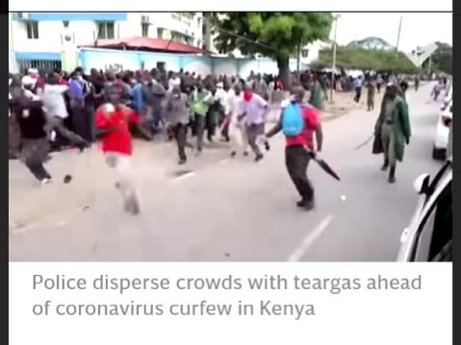rona virus
* The police men as usual were to ensure the rule is upheld and the safety of the citizens however, this turned to be a different thing the police know found a means of exploiting the citizens ups and down, left, right center the police rushed
* The operational hours could not allow the clubs to hold their customers any longer. Many found themselves jobless as the number of clients reduced

## B. THE DOCTOR STYLE

## 

### Who could ever imagine this… everybody on face mask. Everybody resembled a doctor on it’s own

### Failure to have the face mask became an offense payable by forced quarantine, after abond of $5

### At first the prices of the face mask threatened many as only the’ few ‘ could manage to buy then however, it became cheap afterwards as it flooded into the market in large numbers

### Many people were grefull for the mask for it not only helped to reduce the spread of covid 19 but also other diseases

### The worst part now came,, most of the mask were no biodegradable and this pilled lots of trash in the environment, both in water and on land

# The close of schools And worship places

On March 1st of 2020 the president announced of the arrival of the virus into Kenya. And after 2 weeks there was nothing to be done the president called for a closer for the schools to avoid overcrowding and 1m meter social distance which couldn’t be possible In such institutions

**INSTITUTING TOTAL LOCKDOWN**

* Finally to reduce quick transfer of the virus the counties with highest number of infections had no choice to travel out their countries.
* The flights from outside the country was also terminated as it could possibly leak more viruses from other parts, however, the cargo planes were still allowed to operate

**OTHER WAYS THAT WERE INSTITUTED TO REDUCE THE SPREAD OF THE**

**VIRUS**

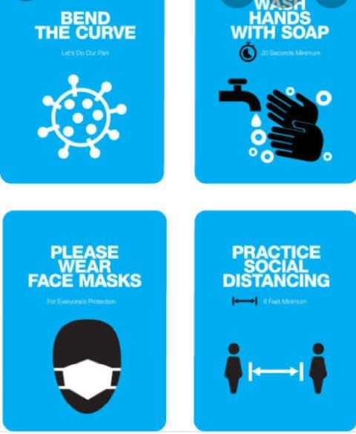

* Frequent sanitizing of hands
* Avoiding handshakes, hugging and kissing friends
* Avoiding crowded places
* Keep Distance at Events and Gatherings: was seid to be safest to avoid crowded places and gatherings where it may be difficult to stay at least 6 feet away from others who are not from your household. If you are in a crowded space, try to keep 6 feet of space between yourself and others at all times, and as it was suggested by the ministry of health

**SOCIAL DISTANCE TIPS THAT WERE SET BY THE MINISTER OF HEALTH**

* When going out in public, it is important to stay at least 6 feet away from other people and wear a mask to slow the spread of COVID-19. Consider the following tips for practicing social distancing when you decide to go out.
* Know Before You Go: Before going out, know and follow the guidance from local public health authorities where you live.
* 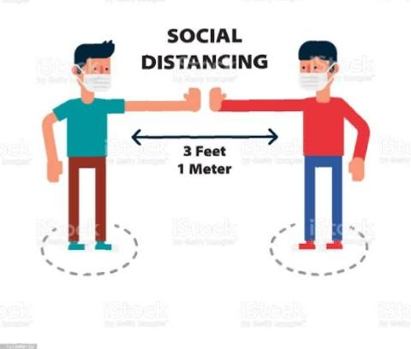Prepare for Transportation: Consider social distancing options to travel safely when running errands or commuting to and from work, whether walking, bicycling, wheelchair rolling, or using public transit, rideshares, or taxis. When using public transit, try to keep at least 6 feet from other passengers or transit operators – for example, when you are waiting at a bus station or selecting seats on a bus or train. When using rideshares or taxis, avoid pooled rides where multiple passengers are picked up, and sit in the back seat in larger vehicles so you can remain at least 6 feet away from the driver. Follow these